DEPARTMENT OF MANAGEMENT SCIENCE

Mathematical Programming

Syllabus

Introduction to linear programming
Formulation of LP models
Graphical solution method
Introduction to computer software (LINDO)

Simplex Algorithm
Sensitivity analysis and parametric programming
Goal programming

Transportation linear programming
Assignment algorithm
Dynamic Programming

Integer programming - solution methods
Integer programming - formulation and modelling

References

Lecture notes are provided. Together with the associated lectures and problem classes, these should be sufficient for you to follow the course. However the following books may provide additional help.

"Model Building in Mathematical Programming" by H.P. Williams (Wiley)
A classic text concentrating on the modelling aspects of mathematical programming containing some instructive large scale examples.

"Model Solving in Mathematical Programming" by H.P. Williams (Wiley)
More detail on the algorithmic aspects of mathematical programming.

"Business Optimisation Using Mathematical Programming" by Josef Kallrath & John M. Wilson (Macmillan 1997)
A good book covering practical modelling issues including discussion of some of the facilities offered in modern commercial software. A CD-ROM containing a student version of XPRESS-MP is included with the book.

In addition, many introductory text books on Management Science or Operational Research have useful chapters on mathematical programming e.g.

“An introduction to Management Science” by David R. Anderson, Dennis J. Sweeny and Thomas A. Williams (West 1991)
Mathematical Programming

1. Introduction

Mathematical Programming (MP) means optimising a given function under certain constraints. The simplest form is Linear Programming (LP), although there are other more complex variations. In this course, you will discover the versatility of LP techniques, their limitations and the information which can be obtained from a Linear Programming 'solution'. Another MP variant known as Integer Programming (IP) will also be discussed.

2. LP Example

A firm manufactures two products P1 and P2 on three machines M1, M2, M3. P1 must be processed on M1 and M2, P2 is processed on all three machines. The manufacturing times for the products are given in the following table:

 | M1 | M2 | M3
P1 | .25 | .4 | 0
P2 | .5 | .2 | .8

Manufacturing times in hours/unit product

Each machine can be used for a total of 40 hours/week. If the firm obtain a profit of £2/unit for product P1 and £3/unit for product P2 then how much of each product should be made each week to maximise profits?

This problem can be formulated in the following way:

Let x1 be the no. units of P1 produced/week.

Let x2 be the no. units of P2 produced/week.

Then we wish to maximise profit function f = 2 x1 + 3 x2

subject to the machine capacity constraints

.25 x1 + .5 x2 ≤ 40 (Machine 1)
.4 x1 + .2 x2 ≤ 40 (Machine 2)
.8 x2 ≤ 40 (Machine 3)

and also to the conditions
x1 ≥ 0, x2 ≥ 0 .

This formulation is an example of a Linear Program (LP).

3. Formal Definitions

A Linear Program is a problem of maximising (or minimising) a linear function of a set of variables when these variables are required to satisfy a set of linear constraints.

Note that the word Programming used in the context of MP, LP etc. simply means 'planning'. This is not to be confused with the 'programming' of computers. Linear Programming (and MP in general) involves optimising a certain function, whereas Computer Programming is instructing a computer to perform a certain task. Of course, one might use a computer program to solve an LP problem.

By a linear function of a set of variablesis meant an expression which can be written in the form c0 + c1 x1 + c2x2 + c3x3 + ... +cnxn where c0,c1,c2,...,cn are constants.

In the previous example the linear function was f = 2x1 + 3x2.

The constant which multiplies a variable is called the coefficient of the variable. Thus the coefficient of x1 in our example is 2.

This function which is to be maximised (or minimised) is called the objective or cost function.

A linear constraint is one which can be written as: a linear function = constant,
a linear function ≥ constant
or a linear function ≤ constant.

In our example there were 3 linear constraints all involving "≤".

A completely general linear programming problem could thus be written in the following way:

Max c1 x1 + c2 x2 + ... + cn xn

subject to a11 x1 + a12 x2 + ... + a1n xn (R1) b1
.. .. .. .. .. .. .. .. ..
.. .. .. .. .. .. .. .. ..
am1 x1 + am2 x2 + ... + amn xn (Rm) bm

where the relationships (R1) ... (Rm) are either "=" "≥" or "≤".
4. Formulation

It is impossible to give a detailed procedure for fomulating linear programs which will work in every case. However, the following simple steps can be helpfully borne in mind.

Step 1: Identify the variables. These are sometimes known as 'activities' and represent things under our control. In our example we used x1 and x2 to represent the amounts of the two products to be produced each week. It is important to have defined the units of each variable carefully, so you understand precisely what xi = 1 means.

Step 2: Identify things which are to be constrained. These are often called "items". In our example these were the times available on the machines.

Step 3: Write down the objective function in terms of the variables.
We had f = 2x.1 + 3x.2

Step 4: Write down the constraints which limit the items.
We had .25 x1 + .5 x2 ≤ 40
.4 x1 + .2 x2 ≤ 40
.8 x2 ≤ 40

Step 5: Add in any additional constraints, such as those involving the ratios of activities.

Step 6. : Don't forget any non-negativity constraints! Our's were x1 ≥ 0, x2 ≥ 0.

5. Examples

1. Formulate the following problem.

An airline company is considering the purchase of new long-range, medium-range and short-range passenger jets. The purchase price would be £3m for each long-range plane, £2m for each medium-range plane and £1.5m for each short range plane, and the company has authorised a maximum commitment of £60m for these purchases. It is estimated that the net annual profit (after subtracting capital recovery costs) would be £200,000, £150,000 and £100,000 for the long-, medium- and short-range planes respectively.

It is predicted that enough trained pilots will be available to the company to man 30 new planes.

If only short-range planes were purchased, the maintenance facilities would be able to handle 40 new planes. However, each medium-range plane is equivalent to 1 1/3 short-range planes, and each long-range plane is equivalent to 1 2/3 short-range planes in terms of the use of the maintenance facilities.

How many planes of each type should be purchased in order to maximise profit? (Ignore the fact that the numbers of planes must be integer).

2. A metal products company produces waste cans, filing cabinets, correspondence boxes and lunch boxes. The manufacture of these products requires sheet Metal of two different thicknesses, called A and B, and of course labour (measured in man hours). One waste can requires .6m2 of A, 4 man hours and generates £1.98 profit. One filing cabinet requires 1.0 m2 of B, 3 man hours, and generates £44.95 profit. One correspondence box requires .2 m2 of A, 2 man hours and generates £9.95 profit. One lunch box requires .3 m2 of A, 3 man hours, and generates £2.98 profit. This week there will be 22.5 m2 of A, 30.0 m2 of B and 190 man hours available.

The company also has a rolling machine which will convert 1 m2 of B to 2.5 m2 of A in one man hour at a cost of £1.

How should the company maximise profit for the week?

3. An amateur dramatic society is putting on a show in a local hall. They must decide how many rows of hard chairs and how many rows of easy chairs to set out. 12 hard chairs can be arranged in one row or 10 easy chairs. They allow 3ft for each row of hard chairs and 3.5 ft for each row of easy chairs and the hall is 84ft long. There are 280 hard chairs and 210 easy chairs available. They decide to provide at least twice as many rows of hard chairs as rows of easy chairs, but the hard chairs should not be more than 90% of the total no. chairs. If they charge 50p for a hard chair and 65p for an easy chair, how many rows of each type should be set out?

4. Three types of crude petroleum are available as follows:

Octane Vapour Gallons Cost per
Rating Pressure Available Gallon

Crude 1 108 4 32000 40p
Crude 2 90 10 20000 24p
Crude 3 73 5 38000 24p

These may be blended to form premium or regular petrol. Premium has an octane rating of at least 100, a vapour pressure of no more than 6, and can be sold at a profit (ignoring the crudes) of 36p per gallon. Regular petrol has an octane rating of at least 80, a vapour pressure of 9 or less, and can be sold at a profit of 28p per gallon.

How should the petrol be blended to maximise profits?
5. A manufacturer wishes to produce 1 ton of an alloy where the percentages of lead and zinc are equal and the percentage of tin lies between 35% and 45%. There are on the market alloys with the following compositions and prices:

Alloy | A | B | C | D
% Lead | 10 | 10 | 40 | 35
% Zinc | 10 | 30 | 50 | 15
% Tin | 30 | 60 | 10 | 50
Price/Ton | 41 | 43 | 58 | 50

How much of each type of alloy should be purchased to minimise cost?

6. The graphical method for LPs with two variables

LPs in practice involve many more than 2 variables. However, it is instructive to see how this special case may be solved graphically. We will again use the manufacturing problem in section 1 which was formulated as:
Max f = 2 x1 + 3 x2
subject to 0.25 x1 + 0.5 x2 ≤ 40 (1) 0.4 x1 + 0.2 x2 ≤ 40 (2)
0.8 x2 ≤ 40 (3)
and x1 ≥ 0, x2 ≥ 0.

The set of points (x1, x2) which satisfy the first constraint can be illustrated as all the points below the line 0.25x1 + 0.5x2 = 40:

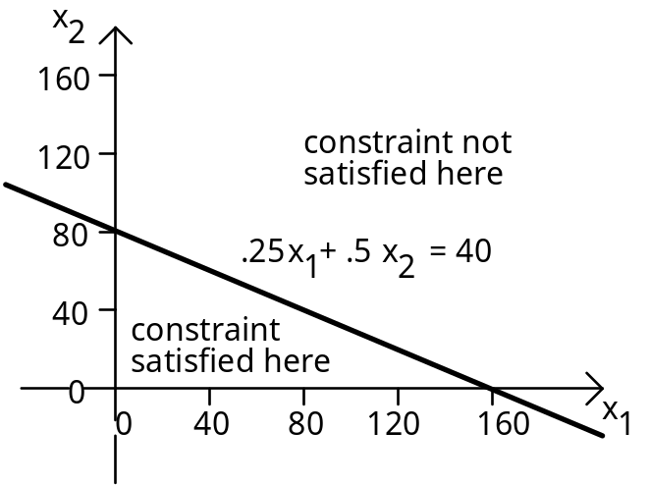
Constraints (2) and (3) can be illustrated in the same way, as well as the non-negativity conditions on x1 and x2. We then find that the area satisfying all the constraints is the one shaded below. The shaded area is known as the feasible region:

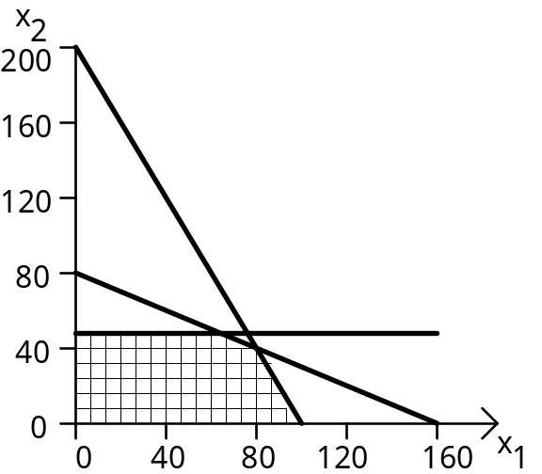

We must now find values of x1 and x2 within the feasible region which maximise the function f = 2x1 + 3x2.

For any particular value of the function, f, a line may be drawn on the graph showing the set of points (x1, x2) which will give that profit:

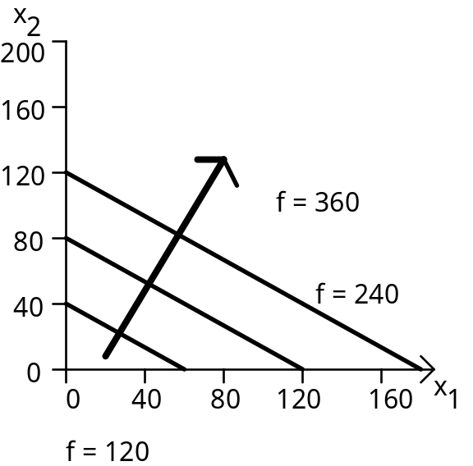

These lines are all parallel and the value of the function increases as the line moves in the direction of the bold arrow.
The question now becomes: "How far can the line be moved in the direction of the arrow and still contain at least one point inside the feasible region?" From the following diagram, the maximum value of f is 280 (at point D), since if the dotted line were to be moved any further in the direction of the arrow it would no longer include a point within the feasible region:

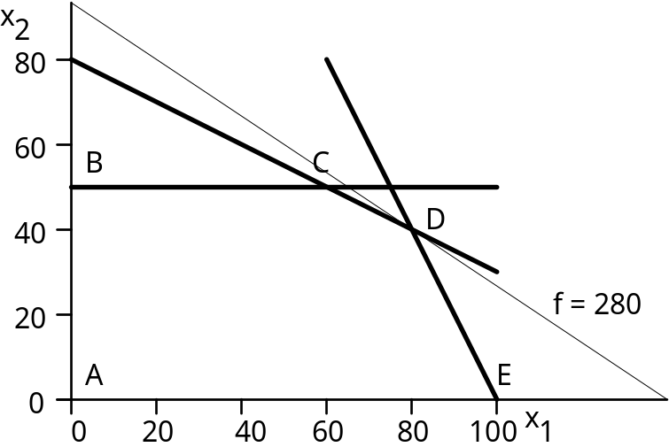

The co-ordinates of D may be read from the graph or alternatively we notice that D is the point at the intersection of lines (1) and (2). Hence we may find D by solving the simultaneous equations: 0.25 x1 + 0.5 x2 = 40
0.4 x1 + 0.2 x2 = 40.

So, x1 = 80, x2 = 40 and the value of f is 280.

This means the firm should produce 80 units of P1 and 40 units of P2 so as to make the maximum possible weekly profit of £280.

There are some points worth noting from this example:

(i) The feasible region was a convex polygon, ie. a straight sided figure with no indentations. This will always be the case with linear inequality constraints.

(ii) The point representing the LP solution was at a vertex (corner point) of the polygon. This too will always be the case, unless the line representing f is parallel to one of the constraint boundaries (i.e., there are two or more alternative optimal vertices).

